(This CRM for AQMS Accreditation Scheme shall have the reference for the compliance to ISO/IEC 17021-1, AS 9104-1, and AS 9101.)

1. | Name of the CB:
2. |   Accreditation Applied for:  Please as applicable | AS 9100 AS 9110 AS 9120
3. | Application reference:
4. | CB’s Documentation (CB to list):
5. | Brief information about the CB:
6. | Summary of Observations:
7. | Recommendations:

(1) | (2) | (3) | (4) |  | (5)
Clause No. AS 9104-1  2022 - 01 | DESCRIPTION | QM/Procedure No/Document No/Format No with Clause No, where a particular requirement is addressed (CB to provide details) | COMPLIANCE |  | NABCB AT Review Comments
Clause No. AS 9104-1  2022 - 01 | DESCRIPTION |  | Yes | No | NABCB AT Review Comments
8. | REQUIREMENTS FOR CERTIFICATION BODIES
8.1 | General Requirements
8.1.1 | CBs shall comply with the requirements of this standard, ISO 17021-1, the AB’s accreditation agreement, and applicable IAF MDs.
8.1.2 | Condition for a Certification Body (CB) to apply for accreditation is that it has been accredited by NABCB for the ISO 9001 scheme for at least 12 full months.  However, accreditation for ISO 9001 from other IAF MLA AB shall also be accepted as per NABCB Procedure BCB 201 (AQMS).  NOTE: During the AQMS accreditation application process, CBs may create contractual arrangements with clients to fulfil accreditation requirements.
8.1.3 | A CB shall not reapply for an AQMS accreditation for at least 12 months following the withdrawal of accreditation or in the event an application for accreditation is terminated by any other ICOP scheme approved AB.
8.1.4 | If a CB applies for AQMS accreditation or scope extension after suspension or withdrawal, the application shall include information about the prior AQMS suspension or withdrawal, with objective evidence of corrections for the causes of the AQMS accreditation suspension or withdrawal.
8.1.5 | CBs shall have personnel with continuing aviation, space, or defence industry involvement through relevant work experience [i.e., aerospace manufacturing/maintenance, National Aviation Authority (NAA), NAIA, or equivalent] to support the CB’s impartiality process.
8.1.6 | CBs shall input and maintain AQMS audit results, certification data, and required ICOP scheme information in the OASIS database.
8.2 | Information Requirements
8.2.1 | CBs shall have legally enforceable arrangements that require AQMS clients to:  - Conform to the applicable requirements of this standard (see section 9 of AS 9104-1);  - Provide data necessary for determination of scope, certification structure, and risk analysis;  - Identify an OASIS database administrator;  - Provide rights of access to facilities, activities, and audit information in support of witnessing CB audits at client’s facilities and oversight for:  - IAQG OPMT, SMS, or RMS (if applicable) representatives; and  - NABCB representatives.
8.2.2 | CBs shall inform AQMS clients on the consequences of not conforming to the legally enforceable arrangements (i.e., withdrawal of certification).
8.2.3 | If restrictions or limitations (e.g., matters of citizenship, proprietary processes) are identified with respect to this access (8.2.1.d AS 9104-1), the restrictions or limitations shall be fully communicated to NABCB. Notification shall occur prior to contracting with the client, to ensure that the AB can support assessment activity at the CB’s AQMS client.
8.2.4 | Certification Documents
8.2.4.1 | AQMS certificates issued by an accredited CB shall, at a minimum, address the following:  - Identify the name of the certified client and entity(ies) they are trading as [e.g., Doing Business As (dba)], the applicable AQMS standard(s) (e.g., AS9100, AS9110, AS 9120, , including the year of revision for the standard(s) and scope of certification.  NOTE: More than one technically equivalent AQMS standard may be referenced on the certificate.  - Include a statement that the certification is in accordance with the applicable standards (e.g., AS9104-1, EN 9104-001) controlling the ICOP scheme including the year of revision.  - Identify the applicable site(s), including the address(es) covered by the scope of certification.  - For each additional site on a certificate, identify the certificate sub-scope (as applicable).  - The dates identified on an AQMS certificate’s current certification cycle shall not exceed three years.  - The issue and expiration date of the current certification cycle and re-issue date (within the current certification cycle), when applicable.
8.2.4.2 | When an organization is certified to both an AQMS standard and the ISO 9001 standard, it is permissible to list both standards on a single certificate if the scope of certification and associated site(s) are identical.
8.2.4.3 | When an ISO 9001 certificate has been issued with a different scope of certification than the AQMS certificate, the ISO 9001 standard shall not be listed on the AQMS certificate.
8.2.4.4 | When the IAQG logo is incorporated into the certificate by the CB, the logo shall be in the form(s) and colors provided by the IAQG. The IAQG logo may not be amended, but may be re-sized to fit the certificate. The IAQG logo shall not receive greater prominence than any other symbol or logo on the certificate. The IAQG logo shall not be used by the CB in any other documents or marketing materials.
8.2.4.5 | The text on the certificate attached in the OASIS database shall be in English. Text in the national language may be added (i.e., bilingual certificate) at the CB’s discretion or as a separate certificate that is identical in all other respects.
8.2.4.6 | Unaccredited AQMS certificates or certificates from unaccredited sources are not permitted. Letters of conformance to AQMS standards and unaccredited audit statements shall be identified as such and not bear any marks or logos of the IAQG, SMS, RMS (if applicable), or NABCB.
8.3 | Structural Requirements for Certification Bodies
8.3.1 | AQMS accredited CBs shall identify a single fixed office location that has overall responsibility for the management and conformance to the ICOP scheme requirements and this standard.
8.3.2 | All processes and required documented information related to management of the ICOP scheme, client applications, client contracts, competencies of personnel, auditing, and certification decisions shall be readily available at the single fixed office location.
8.3.3 | The AQMS accredited CB shall have personnel employed by or directly contracted that are responsible for the management of the ICOP scheme and certification decisions.
8.4 | Resource Requirements for Certification Bodies
8.4.1 | CB personnel involved in the ICOP scheme, according to their role, shall have demonstrated current knowledge and understanding of the following:  - The ICOP scheme (i.e., organization, scope, purpose, processes) and OASIS database functionality;  - The application of the AQMS standards;  - The requirements of this standard.
8.4.2 | CB personnel involved in the technical review and certification decision process shall have demonstrated knowledge of the following:  - AQMS standards for the AQMS accreditations held;  - ICOP scheme standards and requirements, including any applicable resolutions; and  - ASD industry and the regulatory/statutory requirements of sufficient depth to be able to understand the sector specific terminology, processes, practices, and products.  NOTE: Reference AS 9104-3 for definition of industry knowledge.
8.4.3 | CBs shall have authenticated auditors that continually meet the requirements of AS 9104-3.
8.5 | Process Requirements for Certification Bodies
8.5.1 | Organization Certification Analysis Process (OCAP)
8.5.1.1 | The CB in conjunction with applicants and certified organizations shall perform a comprehensive analysis of the organization’s QMS scope, site structure, certification audit program, and risk assessment. The results and supporting information shall be documented and retained (see Figure 1).  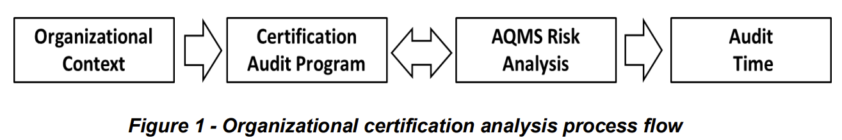
8.5.1.2 | The analysis shall be:  - Conducted prior to initial certification and updated for each surveillance or recertification audit;  - Verified and the verification documented by the CB’s audit team; and  - Updated by the audit team and adjustments made to the audit plan or program, as applicable.  NOTE 1: A tool is available to assist in this process called the Organization Certification Analysis Process (OCAP) Tool.  NOTE 2: Data from Stage 1 activities can be used to document the analysis of the organization.
AS 9101 Rev ‘G’ – Requirements
Cl. 4  AS 9101 Rev G | AUDITING AND REPORTING
4.1 | General
4.1.1 | The audit and reporting process established to assess conformity, including the determination of QMS effectiveness to the 9100-series standards, shall meet the requirements of ISO/IEC 17021-1, as stated in each relevant clause of this standard.
4.1.2 | For Integrated Management System (IMS) audits, the requirements of 9104-1 clause 8.5.2 apply.
4.1.3 | The audit program and associated activities (see 4.2) shall be followed when auditing and certifying organizations to 9100-series standards in the ASD industry.
4.1.4 | The audit process requirements consist of three main parts:  a. The phases of the audit process (see 4.2.1);  b. The common audit activities (see Section 5) used to support each audit phase; and  c. The specific requirements for each audit phase (see Section 6)
4.2 | Audit Program
4.2.1 | The audit program consists of the following phases:  a. Pre-audit activities (see 6.2);  b. Stage 1 audit (see 6.3);  c. Stage 2 audit (see 6.4);  d. Surveillance audit (see 6.5); and  e. Recertification audit (see 6.6)
4.2.2 | Pre-audit activities and Stage 1/Stage 2 audits are applicable for initial certification. A Stage 1 audit can also be utilized for recertification audits and during CB transfer.  NOTE 1: Although ‘Special Audit’ is not listed as a part of the audit program, it can be applicable after initial certification, when directed by special request. The requirements for special audits are defined in 6.7.  NOTE 2: The requirements for certification are defined by the 9104-1 standard.
4.3 | Audit Reporting
4.3.1 | Audit reporting requirements are defined in Table 1.  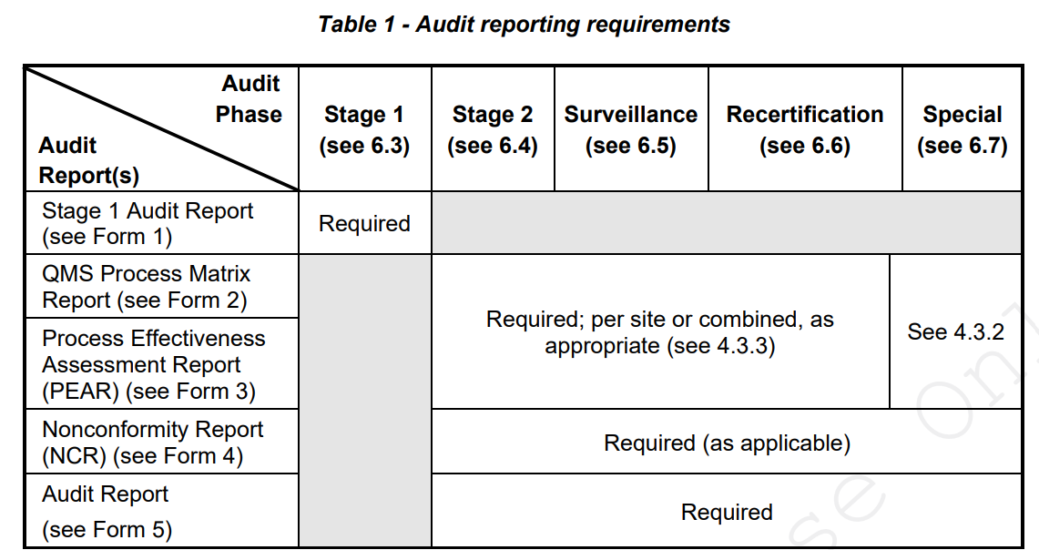
4.3.2 | A QMS Process Matrix Report (see Form 2) and PEAR (see Form 3) shall be issued dependent upon the reason for the special audit, as defined in Table 2.  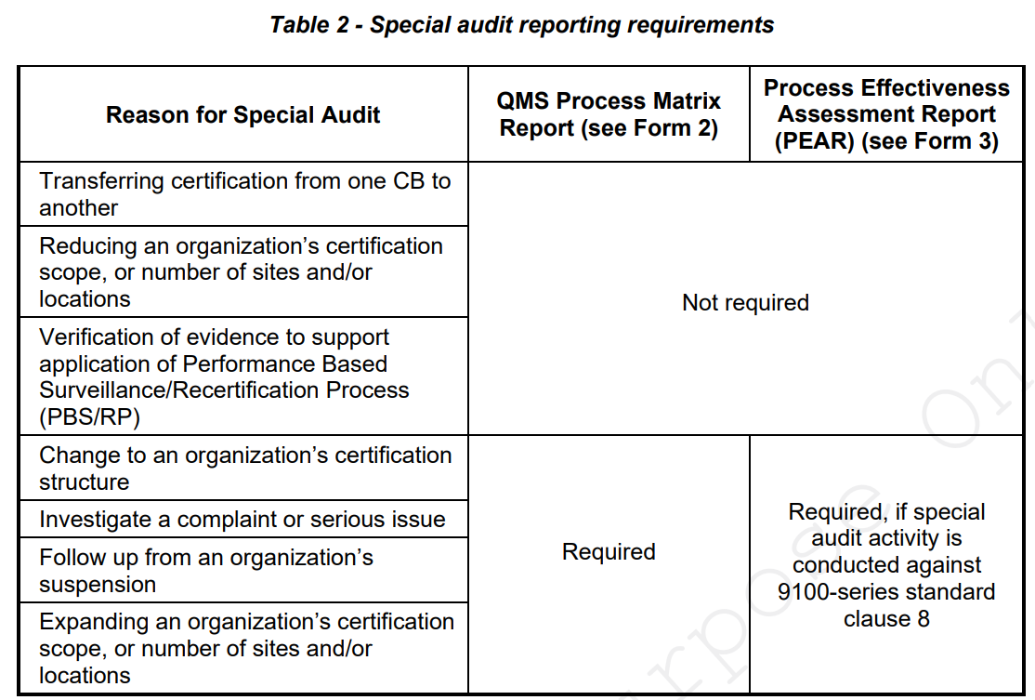
4.3.3 | Recording of process information may be combined into a single PEAR and QMS Process Matrix Report for multi-site organizations, provided that the process is common across the sites. Information recorded shall reflect each site included in the PEAR and QMS Process Matrix Report. The process effectiveness level shall reflect the lowest single value of the various sites assessed.
4.3.4 | All audit reporting, defined within this standard, shall be managed electronically within the Online Aerospace Supplier Information System (OASIS) database, including the audit reports defined in Table 1.  NOTE: In accordance with IAQG Procedure 105.6, representations of the 9101 Rev ‘G’ forms are presented in Appendix B for reference only. These forms and supporting instructions are accessible via the IAQG website.
5. | COMMON AUDIT ACTIVITIES
5.1 | General
5.1.1 | Common audit activities shall be undertaken for each phase of the audit program as defined in Table 3.  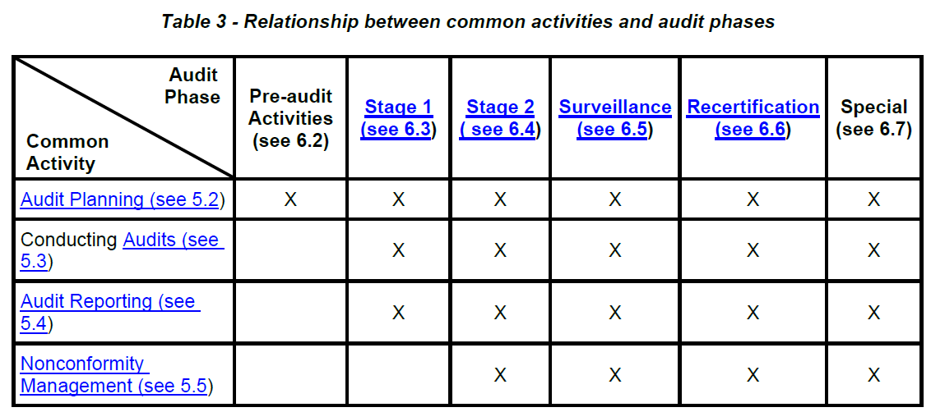
5.1.2 | Stage 1, Stage 2, surveillance, and recertification audit activities shall be described in the audit program established during the ‘Pre-audit Activities’ phase (see 6.2).
5.2 | Audit Planning
5.2.1 | The requirements of ISO/IEC 17021-1 clause 9.2 shall apply.
5.2.2 | Audit teams shall plan audits in accordance with 9104-1 clause 8.5.5.
5.2.3 | Process names shall be consistent in the audit plan, QMS Process Matrix Report (see Form 2), and PEAR (see Form 3) and shall correspond to the process names defined by the organization.
5.2.4 | The audit team leader shall use the organization's customer feedback requests, including those received through the OASIS database (see 9104-1 clause 8.5.12), to assist with audit planning for surveillance and recertification audits, and special audits (when appropriate).
5.2.5 | Audit activities shall be prioritized based upon performance data for business risks that could impact the customer and on processes that are not achieving planned results.
5.2.6 | Audit planning shall take into account, as appropriate to the relevant audit phase:  a. Organization Certification Analysis Process (OCAP) data (see 9104-1 clause 8.5.1);  b. Risks identified in the risk analysis process (see 9104-1 clauses 8.5.1.5 and 8.5.5.6);  c. The sequence and interactions of the organization's processes;  d. The criticality of products, services, and processes, including special processes;  e. Risks associated with QMS, product, service, and process maturity (e.g., new product or service introduction, new process equipment or facilities);  f. Product related safety issues (e.g., airworthiness issues, reporting to customer and/or authorities);  g. Results of internal audits;  h. Previous audit findings (e.g., CBs, customers, regulatory authorities);  i. Previous management review results;  j. Changes to QMS, customer, statutory, or regulatory requirements;  k. Customer satisfaction/performance data;  l. Certification structure [i.e., single site, multi-site (see 9104-1 clause 8.5.1.4.1)];  m. Level of IMS (see 9104-1 clause 8.5.2.1);  n. Use of PBS/RP (see 9104-1 clause 8.5.3);  o. Use of Information and Communication Technology (ICT) (see 9104-1 clause 8.5.4); and  p. Any current IAQG published resolutions.
5.3 | Conducting Audits
5.3.1 | General
5.3.1.1 | The requirements of ISO/IEC 17021-1 clause 9.4 shall apply.
5.3.1.2 | Audit team composition shall meet the requirements of 9104-1 clause 8.5.6.1.
5.3.1.3 | The audit team shall pursue relevant audit trails to assist in the determination of QMS conformity and effectiveness.
5.3.1.4 | Each audit, except for nonconformity follow-up (see 5.5) and special audits (see 6.7) shall include the following, as applicable:  a. Verification of the scope of certification;  b. Verification that changes to QMS, customer, statutory, or regulatory requirements have been implemented since the last audit;  c. Customer satisfaction information, and requested corrective actions and associated responses;  d. Verification of OCAP data submitted, prior to the audit (see 9104-1 clause 8.5.1);  e. An interview with top management;  f. The organization's processes, including their performance and effectiveness, as identified in the audit plan (see 5.2);  g. Continual improvement of the QMS; and  h. Verification of nonconformity status and effectiveness of corrective action resulting from the previous audit.  NOTE: If there is more than one surveillance audit during a year (e.g., every six months), some activities (e.g., interview with top management) may be spread over those audits.
5.3.2 | Conducting the Opening Meeting
5.3.2.1 | The requirements of ISO/IEC 17021-1 clause 9.4.2 shall apply.
5.3.2.2 | In case of a multi-site certification structure:  a. An Authenticated Experienced Auditor (AEA) shall conduct site-specific opening meetings; or  b. An opening meeting shall be conducted with representatives from all sites, either physically or by means of remote meeting methods.
5.3.3 | Site Tour
5.3.3.1 | The audit team leader may choose to conduct a site tour to address any changes in scope or facilities since the last visit, or to familiarize audit team members with the organization's activities.  NOTE: The site tour for a Stage 1 audit is defined in 6.3.1.4.
5.3.4 | Audit Conduct
5.3.4.1 | The requirements of ISO/IEC 17021-1 clauses 9.4.1, 9.4.3, and 9.4.4 shall apply.  NOTE: Audit tools may be developed (e.g., check sheets, questionnaires, supplemental reports) to help auditors in the collection of objective evidence during the audit process.
5.3.5 | Special Processes
5.3.5.1 | When special processes (reference 9100/9110 clause 8.5.1.2) are included in the audit plan, the audit team shall review and evaluate process validation, as well as the monitoring, measuring, and control of these processes, including the following:  a. The retained documented information relating to each audited special process, including the established arrangements and a comparison between actual and planned results;  b. A sample of special processes, including those defined by the customer. For the selected special processes, the audit team shall audit the monitoring and measuring equipment used (e.g., calibration, accuracy) and the method for recording the results. If required, traceability between the process (e.g., batch or load charge identification) and the resulting product/service shall be verified; and  c. In the case of outsourced special processes, the audit team shall verify that the organization's external provider control process addresses these items accordingly. In addition, the audit team shall review the use of customer-designated sources, as required.  NOTE 1: Special processes are managed by using qualified personnel, as determined by the organization and/or customer requirements, and by controlling physical or chemical process characteristics [e.g., temperature, time (process duration), pressure, chemical composition of product, process treatment material (surface treatment solution)].  NOTE 2: If an audit(s) has been performed by a customer or by a specialized independent 3rd party, the audit team can take the audit by these organizations into account. This can include audit results, sampling of the findings, and verification of any reported nonconformities to determine adequate resolution (i.e., no recurrence).
5.3.6 | Identifying and Recording of Audit Findings
5.3.6.1 | The requirements of ISO/IEC 17021-1 clause 9.4.5 shall apply.
5.3.6.2 | The audit team shall complete the QMS Process Matrix Report (see Form 2) to demonstrate which processes and 9100-series standard clauses have been audited, including a summary of objective evidence related to each 9100-series standards clauses (i.e., 4, 5, 6, 7, 9, and 10). For recording a summary of objective evidence related to the operational processes (9100-series standards clause 8), see 5.3.8.  NOTE: If objective evidence for 9100-series standards clauses 4, 5, 6, 7, 9, and 10 is recorded on a PEAR(s), there is no need to repeat these details on the QMS Process Matrix Report. Reference to the applicable PEAR(s) should be stated in the respective QMS Process Matrix Report objective evidence field.
5.3.6.3 | The NCR (see Form 4) shall be used to record each nonconformity against a specific requirement. When nonconformities are identified, the audit team shall categorize the nonconformity as ‘major’ or ‘minor’ (see 3.3 and 3.4 respectively). The need for containment (see 3.1) shall be identified by the audit team.  NOTE: Soft grading of nonconformities and/or identifying them as an opportunity for improvement does not benefit the organization, its’ customers, or the CB. Furthermore, there is risk that the nonconformity would be given a lower priority for correction and/or corrective action, or that no action would be taken and the conditions will expand and/or continue to exist.
5.3.6.4 | For IMS audits, where a nonconformity has been determined in a common process, a single NCR shall be issued referencing the requirements for each 9100-series standard.
5.3.6.5 | Recurrence of the same or similar nonconformity found during consecutive audits at a particular site/location shall be considered as a major nonconformity against the corrective action process (see 9100-series standards clause 10.2).
5.3.7 | Process Results
5.3.7.1 | The audit team shall record measures, targets, and values of KPIs related to each audited operational process (see 9100-series standards clause 8) on the PEAR (see Form 3, Section 2), taking into account the confidentiality of information (see ISO/IEC 17021-1 clause 8.4 requirements).  NOTE: Upon mutual agreement between the organization and the CB, other processes can be recorded on a PEAR.
5.3.7.2 | The audit team shall issue an NCR against the relevant 9100-series standard clause, when the process is not delivering the planned results and appropriate action is not being taken.  NOTE 1: The NCR may be issued against 9100-series standards clause 4.4.1.c and/or 4.4.1.g, if the nonconformity is related to the effective operation and control of the process.  NOTE 2: Nonconformities identified against 9100-series standards clauses 4.4.1.c and/or 4.4.1.g, resulting from multiple PEARs, may be combined into a single NCR.
5.3.8 | Process Realization
5.3.8.1 | The audit team shall record a summary of audit trails and audit evidence related to each audited operational process (see 9100-series standards clause 8) on the PEAR (see Form 3, Section 3).  NOTE: Population of the PEAR may start during the Stage 1 audit to record information reviewed.
5.3.8.2 | The audit team shall issue a NCR against the relevant 9100-series standard clause, when planned activities of a process are not realized or not fully realized.
5.3.9 | Process Effectiveness
5.3.9.1 | The audit team shall evaluate the effectiveness of each audited operational process (see 9100-series standards clause 8) considering:  a. Process realization – the extent to which planned activities are realized (see 3.6); and  b. Process results – the extent to which planned results are achieved (see 3.7).
5.3.9.2 | In order to determine the effectiveness level of the audited process, the audit team shall evaluate the audit evidence arising from the PEAR (see Form 3, Sections 2 and 3) and select the corresponding value, based upon the descriptions given in the Process Evaluation Matrix (see Table 4).
5.3.9.3 | The process effectiveness level derived from the evaluation shall be recorded in the PEAR (see Form 3, Section 4) and documented on the QMS Process Matrix Report (see Form 2).
5.3.9.4 | An effectiveness level of “5” shall only be determined, if the audited process is delivering the planned results and planned activities are fully realized with no nonconformities identified.
5.3.10 | Preparing Audit Conclusions
5.3.10.1 | The requirements of ISO/IEC 17021-1 clause 9.4.6 shall apply.
5.3.11 | Conducting the Closing Meeting
5.3.11.1 | The requirements of ISO/IEC 17021-1 clause 9.4.7 shall apply.
5.3.11.2 | At the site closing meeting, the audit team leader shall, at a minimum, provide the organization with any applicable NCRs (see Form 4) and PEARs (see Form 3) associated with those NCRs.
5.4 | Audit Report
5.4.1 | The requirements of ISO/IEC 17021-1 clause 9.4.8 shall apply.
5.4.2 | At the conclusion of the Stage 1 audit (see 6.3), the Stage 1 Audit Report (see Form 1) shall be compiled and issued. At the conclusion of each certification, surveillance, recertification, and special audit, the audit results shall be recorded and issued using the standard forms (see Table 1).
5.4.3 | Requirements determined as not applicable within the determined scope (see 9100-series standards clause 4.3), as justified by the organization and accepted by the audit team, shall be documented in the Audit Report [see Stage 1 Audit Report (Form 1), QMS Process Matrix Report (Form 2), and Audit Report (Form 5)].
5.4.4 | The content in the Audit Report (see Form 5), including findings, shall give a true and independent view of the conformity status and determination of effectiveness of the QMS in order to give confidence to customers or potential customers; enabling them to draw appropriate conclusions in their supplier selection and surveillance processes.
5.4.5 | For surveillance, recertification, or special audits, the audit team leader shall advise, within the Audit Report (see Form 5), whether the recorded nonconformities should be reason for suspension or withdrawal of the certificate. Failure by the organization to demonstrate effective corrective action to deal with repeat nonconformities (see 3.9) shall warrant suspension of the certification (see 9104-1 clause 8.5.11).
5.4.6 | For IMS audits (see 9104-1 clause 8.5.2.2), a single Audit Report (see Form 5) may be issued. Processes common between the standards may be reported on the same PEAR (see Form 3) and QMS Process Matrix Report (see Form 2).
5.4.7 | The audit documented information shall be made available and published in the OASIS database within the specified time frames (see 9104-1 clause 8.5.7).
5.5 | Nonconformity Management
5.5.1 | The requirements of ISO/IEC 17021-1 clauses 9.4.9 and 9.4.10 shall apply.
5.5.2 | After issuance of a nonconformity, the audit team leader shall:  a. Require the organization to determine and submit the root cause(s), correction to re-establish conformance, and corrective action plan(s) to prevent recurrence of the detected nonconformity on the NCR (see Form 4); and  b. Review and accept the organization’s response on correction, root cause(s), corrective action(s), and supporting corrective action plan(s) in accordance with Table 5.
5.5.3 | When the nature of the nonconformity requires containment action(s) (see 3.1), the audit team leader shall require the organization to:  a. Describe the immediate action(s) ('fix now') taken to contain the nonconforming situation/conditions and to control any identified nonconforming products; and  b. Report the specific containment action(s) and reach agreement on those actions with the audit team leader in accordance with Table 5.  NOTE: Containment action and correction can be reviewed during the audit.
5.5.4 | The NCR (see Form 4) shall be used to document verification of the corrective action. Evaluation and closing of the corrective action plan and associated corrective actions relating to a nonconformity shall not be performed during the audit in which the nonconformity was issued.
5.5.5 | Verification activities shall be carried out, as determined by the audit team leader.
5.5.6 | If the verification of the corrective action cannot be carried out based on a review of the documentation and supporting objective evidence provided by the organization, then verification shall be carried out on-site.
5.5.7 | After verification, the NCR (see Form 4) shall be updated and closed in the OASIS database.
6. | AUDIT PHASE SPECIFIC REQUIREMENTS
6.1 | General
6.1.1 | The requirements of ISO/IEC 17021-1 clause 8.4 shall apply.
6.1.2 | The CB shall require the organization to provide information if any activities, programs, specifications, and/or areas are not accessible because of a restrictive or confidential nature.  NOTE: Denial of access may be due to proprietary/classified information, areas of competitive sensitivity, national security regulations, or requirements invoked by customer contracts. In these instances, the organization and CB should decide on the approach in order to determine the scope of certification.
6.1.3 | Any information considered confidential by the organization's customers and/or authorities, or the organization itself shall not be reported, unless approved by the audited organization.
6.1.4 | The organization shall provide the OCAP data to the CB a minimum of 90 days prior to each initial, surveillance, and recertification audit (see 9104-1 clause 9.1.10).
6.1.5 | The CB and audit team leader shall create an entry and set up the audit in the OASIS database, prior to each audit.
6.2 | Pre-Audit Activities (Initial Audit)
6.2.1 | General
6.2.1.1 | The requirements of ISO/IEC 17021-1 clauses 8.5 and 9.1.3 shall apply.
6.2.1.2 | The scope of certification shall be determined (see 9104-1 clause 8.5.1.3.2).
6.2.1.3 | The scope of certification shall not include processes that were not audited to sufficient depth to verify an organization's conformity, including the determination of effectiveness. Unaudited processes may be included in the scope of certification, if it can be demonstrated that they are similar to processes that were assessed and the same QMS documented information and controls are invoked. Justification for this approach shall be included in the audit report.
6.2.2 | Application
6.2.2.1 | The requirements of ISO/IEC 17021-1 clause 9.1.1 shall apply.
6.2.2.2 | The CB shall require the organization to provide the following:  a. Number of employees associated to ASD business (i.e., full time, part time, temporary) and percentage of the total workforce; and  b. Identification of the key (e.g., top five) customers.
6.2.3 | Application Review
6.2.3.1 | The requirements of ISO/IEC 17021-1 clause 9.1.2 shall apply.
6.2.4 | Requirements for the Certification Body
6.2.4.1 | Before scheduling the Stage 1 visit, the CB shall:  a. Appoint an audit team leader that has sufficient knowledge of the activities and the intended scope of certification to determine auditor required competences and/or whether technical experts are needed;  b. Take into account any additional requirements/requests from the organization and/or the organization's customer(s), as long as they are not in conflict with the provisions of ISO/IEC 17021-1, to optimize the benefit of the certification audit program; and  c. Ensure that audit time is identified in accordance with 9104-1 clauses 8.5.1.6, 8.5.2, and 8.5.3.
6.2.5 | Requirements for the Audit Team Leader
6.2.5.1 | Before scheduling the Stage 1 audit, the audit team leader shall:  a. Determine if information received during the pre-audit phase is sufficient to proceed to the Stage 1 audit; and  b. Verify the audit time for the Stage 1 and Stage 2 audits.
6.3 | Stage 1 Audit
6.3.1 | General
6.3.1.1 | The requirements of ISO/IEC 17021-1 clause 9.3.1.2 shall apply.
6.3.1.2 | Before the Stage 1 audit, the audit team leader shall be confirmed and possible audit team members shall be identified. After the Stage 1 audit, the team composition for the Stage 2 audit shall be reviewed based on information received and observed during the Stage 1 audit; followed by the final appointment of the team members.
6.3.1.3 | The Stage 1 audit shall:  a. Be performed by the audit team leader appointed for the initial audit with audit team assistance, if needed; and  b. Include an on-site evaluation (see 9104-1 clauses 8.5.5.1 and 8.5.5.2).
6.3.1.4 | The Stage 1 audit shall include a tour of the site facilities. This will enable the audit team to gain a greater understanding of the organization's processes, equipment, areas, products, and state of readiness in preparation for the Stage 2 audit.
6.3.2 | Collection of Information
6.3.2.1 | During the Stage 1 audit, the audit team shall collect sufficient information that allows the CB to:  a. Confirm the audit program;  b. Review the need for additional technical experts and/or auditors to compose a competent audit team;  c. Confirm the number of employees associated to ASD industry business (i.e., full time, part time, temporary) and percentage of total work force (as declared by the organization during the application review phase);  d. Review the key (e.g., top five) customers, as declared by the organization during the application review phase;  e. Confirm any customer/regulator specific approvals and associated requirements, if applicable;  f. Confirm the number of shifts and shift patterns;  g. Determine restricted areas and proprietary information, including confidentiality requirements;  h. Determine any additional audit activities, as needed, for the fulfillment of the requirements for initial certification;  i. Confirm the OCAP data, submitted prior to the audit (see 9104-1 clause 8.5.1); and  j. Schedule the Stage 2 audit activities.
6.3.3 | Review of the Organization
6.3.3.1 | During the Stage 1 audit, the audit team leader shall require the organization to provide the necessary documented information for review, including the following:  a. Requirements determined as not applicable within the scope of the QMS, including justification by the organization (see 9100-series standards clause 4.3);  b. QMS documented information;  c. Evidence that the requirements of the applicable 9100-series standards are addressed by the organization's documented information established for the QMS (see 9100-series standards clause 4.4);  d. Evidence of customer performance (i.e., product/service quality, OTD, complaints), process performance, and performance of quality objectives;  NOTE: The data should be sufficient to allow the audit team leader to make a judgment on performance and trends.  e. export limitations/controls, if applicable [e.g., International Traffic in Arms Regulations (ITAR), Export Administration Regulation (EAR)];  f. evaluation of certification structure (i.e., single site, multi-site) eligibility for determination of audit time and site coverage (see 9104-1 clauses 8.5.1.4 and 8.5.1.6); and  g. level of management system integration (see 9104-1 clause 8.5.2), as applicable.
6.3.4 | Stage 1 Conclusions
6.3.4.1 | The audit team leader shall use the results of the organization review and additional information obtained from the site tour to:  a. Develop a plan for the Stage 2 audit, that includes any additional customer and regulatory requirements;  b. Verify the proposed scope of certification (see 9104-1 clause 8.5.1.3);  c. Verify the information used for audit time calculation (see 9104-1 clause 8.5.1.6) and recommend adjustment, as needed;  d. Update the Stage 2 audit plan based upon any confirmed audit time adjustments, as applicable;  e. Recommend adjustments to the composition of the audit team for the Stage 2 audit, including the need for any technical experts or translators, as applicable;  f. Verify the information used for determination of the certification structure; and  g. Identify any changes required to the contract and communicate those revisions to the organization and CB.
6.3.4.2 | The CB shall review the status of the areas of concern to determine preparedness for the Stage 2 audit.
6.4 | Stage 2 Audit
6.4.1 | The requirements of ISO/IEC 17021-1 clauses 9.3.1.3, 9.3.1.4, and 9.5.3 shall apply.
6.4.2 | All requirements of the applicable 9100-series standard (except requirements determined as not applicable within the determined scope) and the organization's processes that are part of the QMS shall be audited.
6.4.3 | Detailed audit findings, including reference to the audited processes and documented information shall be recorded (see 5.3.6).
6.4.4 | During the opening meeting, the audit team leader shall reconfirm with the organization the issues identified during the Stage 1 audit (see 6.3).
6.4.5 | After the opening meeting, the audit team leader shall revise the audit plan, as needed, due to changes since the Stage 1 audit (e.g., personnel changes, department/business unit reorganization, new customer complaint) or any objections from the organization that impact the audit.  NOTE: Revision to the audit plan can have an impact on the audit time.
6.5 | Surveillance Audit
6.5.1 | The requirements of ISO/IEC 17021-1 clause 9.6.2 shall apply.
6.5.2 | All requirements of the applicable 9100-series standard (except requirements determined as not applicable within the determined scope) and the organization's processes that are part of the QMS shall be audited across the surveillance audits, during the certification cycle.
6.5.3 | The audit method(s) to be used (e.g., audits on specific problems, areas, products, or sub-processes) shall be based on the outcome of the audit team’s review of the OCAP data (see 6.1.4) and information gathered during audit planning (see 5.2.6).
6.5.4 | Detailed audit findings, including reference to the audited processes and documented information shall be recorded (see 5.3.6).
6.5.5 | The audit team shall verify the effectiveness of corrective action(s) taken for nonconformities identified during the previous audit, if applicable.
6.6 | Recertification Audit
6.6.1 | The requirements of ISO/IEC 17021-1 clauses 9.5.4 and 9.6.3 shall apply.
6.6.2 | The audit method(s) to be used (e.g., audits on specific problems, areas, products, or sub-processes) shall be based on the outcome of the audit team’s review of the OCAP data (see 6.1.4) and information gathered during audit planning (see 5.2.6).
6.6.3 | Any change of customer and/or regulatory approval status shall be reviewed by the audit team to determine the impact on the certification status.
6.6.4 | All requirements of the applicable 9100-series standard (except requirements determined as not applicable within the determined scope) and the organization's processes that are part of the QMS shall be audited.
6.6.5 | The organization's QMS, associated processes, and documented information shall be reviewed for changes.
6.6.6 | Detailed audit findings, including reference to the audited processes and documented information shall be recorded (see 5.3.6).
6.6.7 | The audit team shall verify the effectiveness of corrective actions taken for nonconformities identified during the previous audit, if applicable.
6.7 | Special Audit
6.7.1 | The requirements of ISO/IEC 17021-1 clause 9.6.4 and 9104-1 clause 8.5.10 shall apply.
6.7.2 | Special audits shall be coordinated with the organization, prior to the visit. The organization shall be given information about the specific reason and subject of the visit.
6.7.3 | Detailed audit findings, including reference to the audited processes and documented information shall be recorded (see 5.3.6).
AS 9104-1 – Requirements
8.5.1.3 | Organizational Context
8.5.1.3.1 | CBs shall engage with applicants and certified organizations to determine the context of the organization and scope of certification.
8.5.1.3.2 | Scope statements shall summarize the organization’s products, services, and supporting activities (e.g., manufacture, design, repair, distribution, servicing, testing), and align with the organization’s AQMS.  NOTE: Non-applicable AQMS requirements should be considered when determining the certification scope statement.
8.5.1.3.3 | The AQMS standard(s) (i.e., AS 9100, AS 9110, or AS 9120) utilized for certification shall be selected based on the organization’s scope of certification.  NOTE: Refer to the “Intended Application” of the AQMS standards to determine the selection of the appropriate standard.
8.5.1.3.4 | CBs shall require that organizations provide information regarding the use of additional aerospace standard(s) listed within the IAQG Standards Register during the initial Stage 1 audit and update, as needed, prior to surveillance or recertification audits.  NOTE: CB auditors should use information about additional IAQG standards to support the audit scope.  Please refer below table – International Aerospace Quality Group standards matrix of AS 9104-1  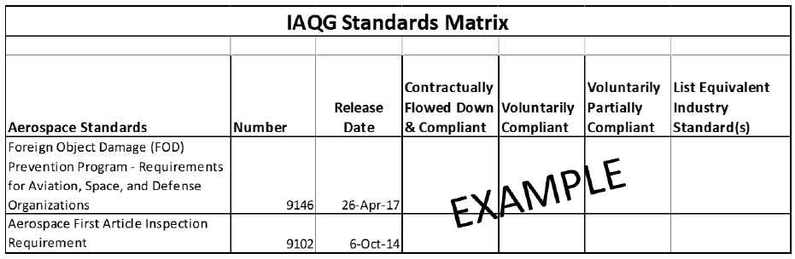
8.5.1.4 | Certification Audit Program
8.5.1.4.1 | Definitions in IAF MD 1 shall be used for selecting the appropriate certification structure.  - A single site certification structure shall have one address documented on the certificate and in the OASIS database. A single site may have additional buildings and addresses at the same geographical location; however, these buildings and addresses will not be listed in the OASIS database.  - For a multi-site certification structure, the central function and all applicable sites shall be listed on the certificate and in the OASIS database.  NOTE 1: Considerations for a single or multi-site structure can include additional buildings such as a warehouse, test facility, or other structures.  NOTE 2: If additional addresses are needed to define the business locations or sites to support customer interactions, then a multi-site structure may be appropriate.  NOTE 3: The central function may be a virtual site or part of a site (e.g., the organization’s headquarters).
8.5.1.4.2 | Sampling per IAF MD 1 of a multi-site structure for all AQMS certification, recertification, or surveillance audits is not permitted.
8.5.1.4.3 | In addition to IAF MD 1, the audit program for multi-site organizations shall include the following:  - All sites and the entire scope of certification shall be audited during initial certification and recertification; and  - During surveillance audits, the central function and approximately 50% of the sites shall be audited in year 1; the central function and all remaining sites shall be audited in year 2.
8.5.1.4.4 | The determination and justification of the certification structure and audit program shall be retained as documented information.  NOTE: The CB may approach NABCB to request approval or deviation for extraordinary events in accordance with guidance defined in IAF ID 3.
8.5.1.5 | Aerospace Quality Management System Risk Analysis
8.5.1.5.1 | Risk analysis shall include verifiable data linked to the organization’s structure, complexity, and performance that includes the following:  - The complexity of the organization and its management system (reference IAF MD 5 and Figure 2 – Organization complexity risk level of AS 9104-1);  - The organization’s internal audit program (Refer Table 5 – Internal audit program risk analysis of AS 9104-1); and  - The organization’s performance (Refer Table 6 – Performance based elements risk analysis of AS 9104-1).
8.5.1.5.2 | The overall organizational risk for use in determination of site audit duration shall be in accordance with Table 7 (Refer – Table 7 Organizational risk determination of AS 9104-1).
8.5.1.5.3 | When “Organization” is referenced as the data source within Table 7 of AS 9104-1, the CB shall utilize the organization’s performance measures and associated risk determination (i.e., exceeds, meets, or below) to support completion of the risk analysis and conformance to this standard.  NOTE: The organization’s metrics and performance targets should align with customer requirements.
8.5.1.5.4 | The output of the risk analysis shall be retained as documented information by the CB and indicate a level of risk (i.e., high, medium, or low), based on the evaluation of the organization’s performance and associated risk factors (reference 8.5.1.5.1).
8.5.1.6 | Audit Time
8.5.1.6.1 | Requirements are established by this standard for audit time (i.e., initial, surveillance, and recertification audits) and shall be based upon the scope, audit program, risk analysis, and size of the organization.
8.5.1.6.2 | Audit duration shall be calculated by site for multi-site and single site structures.  NOTE: The OCAP tool is designed to provide the basis for the audit time calculation.
8.5.1.6.3 | Audit Duration Requirements  The CB shall use the audit duration baseline defined in Table 8 of AS 9104-1. Per IAF MD 5, audit time includes both on-site and offsite time (i.e., planning, report writing, and auditing). Audit duration includes the time from the opening meeting to the closing meeting.  Audit duration shall only include audit activities. Travel, meals, extended break times, and non-audit activities are not included.  NOTE: Time for report writing, from the total audit time, can be added to the audit duration.
8.5.1.6.4 | Audit Duration Calculations  - Audit duration shall be calculated using the total number of personnel at each site within the scope of certification at the time of the audit in accordance with Table 8 of AS 9104-1 for initial (Stage 1 and Stage 2), surveillance, and recertification audits.  - Determination of audit duration for the central function as defined by IAF MD 1, within a multi-site structure, shall include personnel supporting activities of the central function.
8.5.1.6.5 | Audit Duration Adjustments  - The risk analysis (see 8.5.1.5) results shall be used to adjust the audit duration, in accordance with Table 9 of AS 9104-1, as appropriate.  - The applicability of site processes shall be used to adjust audit duration. Allowable audit duration reductions are defined in Table 10 of AS 9104-1.  - Audit duration adjustments shall be calculated independently and be the cumulative time, as depicted in Figure 3 of AS 9104-1.  - The total reduction by site after all adjustments (including rounding) shall not exceed 50% of the audit duration per Table 8 of AS 9104-1.  - Time shall be added to the audit duration by site for the use of translators.  - Time shall be added to audit duration by site for the contractual requirements identified within the IAQG Standards Matrix (reference Table 4 of AS 9104-1).  - Time shall be added to the audit duration for verification of corrective actions from previous audit nonconformities, when necessary, at the appropriate location(s).  - The calculated audit duration shall be rounded to the nearest half day.  - Site audit duration may be re-allocated to another site to support increased complexity and risk mitigation. Re-allocation shall not reduce the audit duration per Table 8 of AS 9104-1 at any individual site by more than 50%.  - The re-allocation of audit duration across sites shall not reduce the total calculated audit duration.
8.5.1.6.6 | To determine audit time, 20% shall be added to the total audit duration for all sites. This added time is used for OCAP analysis, audit planning, and report writing.  NOTE: Rounding of audit time is not required.
8.5.1.6.7 | The calculated audit time shall be retained as documented information including audit duration, adjustments, and justification.
8.5.2 | Integrated Management System Audits
8.5.2.1 | Audits of an Integrated Management System (IMS) shall be conducted in accordance with the requirements of IAF MD 11, this standard, and the following:  - During the OCAP risk analysis (see 8.5.1.5), the level of integration of the management system shall be established;  - For an IMS with fully integrated AQMS standards, CBs shall calculate the audit duration for each standard individually; then, take the standard with the highest amount of audit duration and add 50% of the audit duration for each additional standard (i.e., Total Audit Duration = 9100 + 50% of AS 9110 calculation + 50% of AS 9120 calculation); and  - For all other IMS audits, including organizations comprising of an ISO 9001 QMS and an AQMS with different scopes, CBs shall comply with IAF MD 11 requirements and the audit duration time for the AQMS standard(s) shall not be reduced.  NOTE: An AQMS standard is inclusive of ISO 9001, when the certification scopes are identical. It is not to be considered as a separate management system standard.
8.5.2.2 | The audit of integrated AQMS standards shall be conducted and documented in accordance with the AS 9101 standard.
8.5.3 | Performance Based Surveillance/Recertification Process
8.5.3.1 | CBs shall apply to their AQMS accrediting AB and obtain approval, prior to implementation of PBS/RP for any client.
8.5.3.2 | CBs shall have processes and maintain documented information for application of PBS/RP for certified organizations.
8.5.3.3 | When a CB’s client applies for PBS/RP, the requirements of 9.2 and Appendix D of AS 9104-1 shall apply.
8.5.3.4 | Multi-site organizations eligible for PBS/RP (see Appendix D of AS 9104-1) shall include the following auditing program requirements:  - During annual surveillance, the central function and 33% of the sites, rounded up to the nearest whole number;  - At recertification all remaining sites and the central function; and  - Each site, process, and AQMS standard clause shall be audited at least once every 48 months.
8.5.3.5 | When using PBS/RP, audit durations shall be calculated as follows:  - For a single site structure using PBS/RP, audit duration may be reduced up to 33% from the Table 8 calculation and 8.5.1.6.5.d applies.  - For multi-site structures using PBS/RP, audit duration for each site shall be calculated using the “Recertification Audit Duration” requirements from Table 8 of AS 9104-1 for surveillance and recertification. This number may be reduced up to 33% per site and 8.5.1.6.5.d applies.  NOTE: This applies at initiation of PBS/RP and at any time during the certification cycle.  - For multi-site structures using PBS/RP for the central function, audit duration shall be calculated using the “Surveillance Audit Duration” requirements from Table 8 and may be reduced 33% for surveillance and recertification.  NOTE: The requirements of 8.5.1.6.3 and 8.5.1.6.5 are applicable to PBS/RP (see Appendix D of AS 9104-1).
8.5.3.6 | CBs shall evaluate and make appropriate process adjustments, as depicted in Table D.2 of AS 9104-1, when organizations who are approved for PBS/RP are not in conformance with continuing requirements.  NOTE: Site risk analysis should be performed when there is available site data to determine on-going effectiveness of PBS/RP.
8.5.4 | Use of Information and Communication Technology in an Audit Program
8.5.4.1 | When utilized, Information and Communication Technology (ICT) shall be applied in accordance with IAF MD 4.
8.5.4.2 | Where a physical location of a site exists, and ICT is utilized, a maximum of 50% of the audit duration may be conducted remotely.
8.5.4.3 | Where a physical location of a site does not exist (i.e., a virtual site -reference IAF MD 1), ICT shall be utilized in accordance with IAF MD 4.
8.5.4.4 | The use of ICT by a CB shall not reduce the calculated audit time (see 8.5.1.6).
8.5.5 | Planning Aerospace Quality Management System Audits
8.5.5.1 | Initial Stage 1 audits shall include on-site evaluation of the client’s site-specific conditions.
8.5.5.2 | For multi-site organizations, the Stage 1 audit shall include an evaluation of the identified central function. In addition, a relevant number of sites representative of different technologies and dissimilar activities shall be included in the Stage 1 audit.
8.5.5.3 | Stage 1 and Stage 2 audits shall not be performed on the same day or on consecutive days (i.e., back-to-back). If the time between the Stage 1 and Stage 2 audits exceeds six months, an additional Stage 1 audit shall be conducted.
8.5.5.4 | Initial Stage 2 audits shall be conducted by auditing each site included in the scope of certification to the complete, applicable AQMS standard. In addition, all processes as defined by the organization shall be audited, prior to a certification decision being made.
8.5.5.5 | When auditing organizations with an existing ISO 9001 certificate, that are upgrading to an AQMS standard, a full initial audit (Stage 1 and Stage 2) of all requirements for the applicable AQMS standard (i.e., ISO 9001 and ASD industry additional requirements) is required.
8.5.5.6 | Audit plans shall address risks identified in the risk analysis process (reference 8.5.1.5), including a focus on organizational change, organizational performance, OASIS database feedback, and contractual requirements.
8.5.5.7 | When an audit plan includes activities that occur on multiple shifts, the time used shall be justified and proportional to the level of activity for each shift.
8.5.5.8 | All applicable clauses of the AQMS standard, including all of the organization’s defined processes, shall be audited within each certification cycle.  NOTE: The recertification audit should be planned and conducted a minimum of three months before the expiry date of the current certificate.
8.5.5.9 | The verification of corrective actions from previous audit nonconformities shall be identified in the audit plan.  NOTE: Additional time may be added to the eight-hour audit day for corrective action verification where the associated process is not included in the audit plan.
8.5.6 | Aerospace Quality Management System Audit Teams
8.5.6.1 | AQMS audits teams shall conduct and document audits in accordance with the requirements of this standard, the AS 9101 Rev ‘G’ standard, and the following:  - The audit team leader shall be an AEA (as defined by AS 9104-3) that participates in and is responsible for the conduct of the entire audit.  - An AEA shall participate at each site during the entire audit duration, including each site audited utilizing ICT.  - Audit teams shall include authenticated auditors (i.e., AEAs, AAs) for the standards being audited.  - AEAs or Aas shall not audit the same site for more than six consecutive annual audits (i.e., initial, surveillance, and recertification), excluding special audits, unless a deviation in advance of the audit is obtained from the accrediting AB. Any request for deviation shall be documented and include supporting justification.  - AEAs shall not audit an organization that has transferred to a new CB for a period of 24 months from the transfer certification decision, when the AEA has audited that organization in the preceding 24 months.
8.5.6.2 | When a CB receives a client objection to the appointment of an audit team member and the team member is removed based on a valid objection, the supporting information on the objection shall be retained as documented information.
8.5.7 | Audit Team Conclusions and Reporting
8.5.7.1 | The audit report (reference AS 9101) shall be completed and available to the client in the OASIS database within 14 days of the closing meeting.  In addition, at the closing meeting, the audit team leader shall, at a minimum, provide the organization with any applicable NCRs (see Form 4 of AS 9101) and PEARs (see Form 3 of AS 9101) associated with those NCR.
8.5.7.2 | Any proprietary or confidential data that is referenced and then not included in the audit report shall be retained and the information location identified.
8.5.7.3 | The audit report shall be published in the OASIS database within 30 days after a certification decision or 90 days after the closing meeting for all other audits.
8.5.8 | Certification Decisions
8.5.8.1 | The certification decision process for initial certification, changes in certification (e.g., extension to scope, restoration), and recertification shall require that all nonconformities are accepted and associated corrective actions are effective. The client’s AQMS shall be returned to conformity, prior to the certification decision.
8.5.8.2 | CBs shall only certify an organization’s AQMS, when the certification scope is in alignment with 8.5.1.3.2.
8.5.9 | Transfer of Certificates
8.5.9.1 | In addition to ISO/IEC 17021-1 and IAF MD 2 requirements, the following apply:  - Only valid certifications from a CB with an AQMS accreditation from an ICOP scheme approved AB shall be eligible for transfer.  - The accepting CB shall generate a new OCAP (or equivalent) and perform a special audit (see 8.5.10) as part of the pre-transfer review.  - When the OCAP risk analysis is high risk or an outstanding major nonconformance (reference AS 9101) exists, then a special audit shall be performed on-site.  - For organizations with PBS/RP, CBs shall assure conformance to the requirements as defined in Appendix D, Table D.1, AS 9104-1 prior to transfer.  - The accepting CB shall not issue certification to the transferring client unless:  - All nonconformities have corrections, corrective action, and verification accepted by the current CB; or  - The accepting CB assures that nonconformities are accepted and associated corrective actions are effective; and  - The client’s AQMS shall be returned to conformity, prior to the certification decision.
8.5.9.2 | The accepting CB shall not use the initial certification process to avoid resolving outstanding nonconformities.  NOTE: The accepting CB may request and obtain the relevant OASIS database information necessary to assure nonconformity closure.
8.5.9.3 | The current CB shall cooperate with the accepting CB to facilitate the transfer. The accepting CB shall use the OASIS database feedback process to create documented evidence of communication with the current CB.
8.5.9.4 | The current CB shall not use notification of a transfer as justification for suspension or withdrawal of the existing certificate before the transfer process to the accepting CB is completed.
8.5.10 | Special Audits
8.5.10.1 | Special audits shall be conducted, during the certification cycle, in response to one of the following situations:  - An organization’s request to extend their existing certification scope, revise certification structure, increase the number of site(s), and/or change in site location(s);  - Transferring certification from one CB to another;  - A complaint of an ethical nature (with sufficient objective evidence); or  - A complaint or notification regarding a significant AQMS nonconformity (with sufficient objective evidence).  NOTE: A special audit may also be conducted to:  - Verify corrective action effectiveness;  - Assess the reduction in scope or sites;  - To assess a customer or other relevant interested party concern; or  - Investigate an issue concerning the AQMS certification.
8.5.10.2 | Special audits in support of a complaint or notification of an ethical nature shall be conducted within 30 days of the receipt of the complaint or notification.
8.5.10.3 | Special audits shall be conducted on-site for scope extensions or the addition of site(s) to an existing certification.  NOTE: Other types of special audits (e.g., complaints, transfers, corrective actions) may be conducted remotely (reference IAF MD 4).
8.5.10.4 | Audit duration for the addition of a site(s) using a special audit shall be calculated using the initial audit duration for the site(s). The audit duration may be modified based on the results of an updated OCAP that includes the additional site(s).
8.5.10.5 | A special audit used for adding a site(s) to an existing AQMS certificate using PBS/RP shall require a certificate decision. The site(s) added to the PBS/RP program shall be audited using recertification criteria during surveillance, prior to the next recertification decision.
8.5.11 | Suspending, Expiring, or Withdrawing Certification
8.5.11.1 | CBs shall suspend certification and retain documented information supporting the suspension decision for any of the following conditions:  - When an organization fails to re-establish conformance within 90 days from the date the nonconformance was issued; or  - When an ethical complaint (e.g., code of conduct) or ethical related nonconformity has been substantiated with supporting objective evidence.  NOTE: Nonconformity management requirements are identified in AS 9101 Rev G.
8.5.11.2 | The following recertification situations shall apply:  - If the recertification decision is not completed prior to the certification expiry date, the certificate will expire.  - If the recertification activities have started (i.e., on-site or remote audit activity has started), the certification decision shall be completed within six months of the certificate expiration and the certificate can be restored.  - If the audit has not started before the certificate expiration date, then the certification will expire and the organization shall be treated as a new certification application.
8.5.11.3 | CBs shall update the OASIS database within 14 days of the decision to suspend or withdraw an AQMS certificate
8.5.12 | Complaints and Online Aerospace Supplier Information System Database Feedback Process
8.5.12.1 | CBs shall manage and resolve complaints or issues communicated through the OASIS database feedback process (reference 12.2) and shall ensure:  - That feedback is reviewed and a response, when requested, is provided within 30 days from receipt.  NOTE: An acknowledgement does not satisfy the 30-day response requirement.  - When the feedback is based on a complaint regarding a certified organization, the CB shall initiate their complaint resolution process. The CB shall ensure that the complainant is kept informed on the progress for resolution. If the CB determines on short notice that a special audit is necessary to investigate and resolve the complaint, this audit shall take place within 90 days from the receipt of the complaint.  - When the feedback is based on a complaint regarding the CB, the CB shall initiate their internal complaint process and information on results reported to the complainant within 60 days from the date of the complaint.  - That complaints related to ICOP scheme application requirements that cannot be resolved by a CB are referred to the AB.
8.5.12.2 | CBs shall formally respond in the OASIS database to actions originating from 9104/2 oversight assessment activities.
8.6 | Quality Management System Requirements for Certification Bodies
8.6.1 | In addition to ISO/IEC 17021-1 requirements, CBs shall identify and incorporate appropriate information and requirements from the ICOP scheme into their processes.

